

dATA COMMUNICATION AND NETWORKS

LAB # 02



October 3, 2022

MUHAMMAD NOMAN

35152- BSCS

**PRACTICE TASK:**

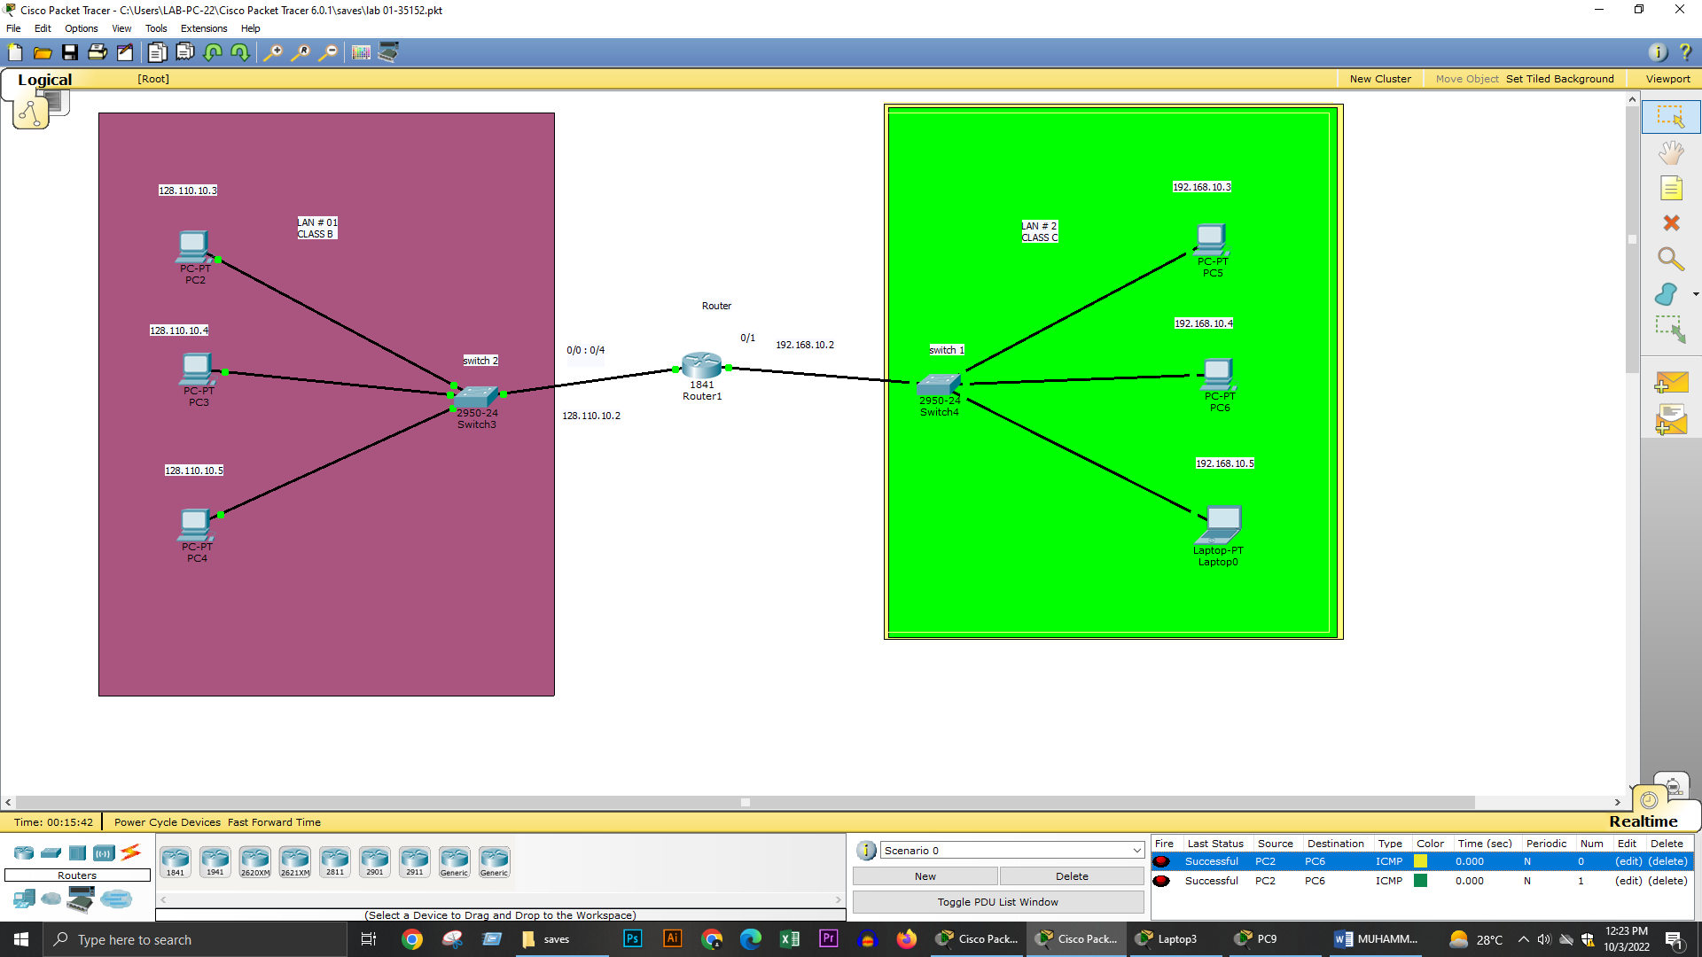



**TASK 1:**

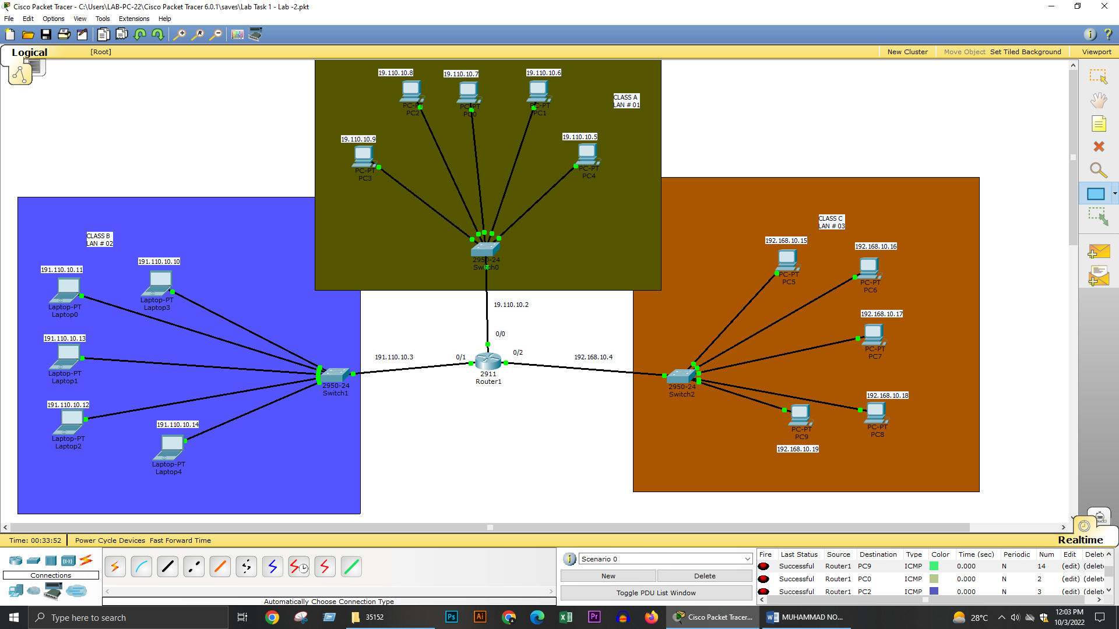

**ROUTER CONFIGURATION:**

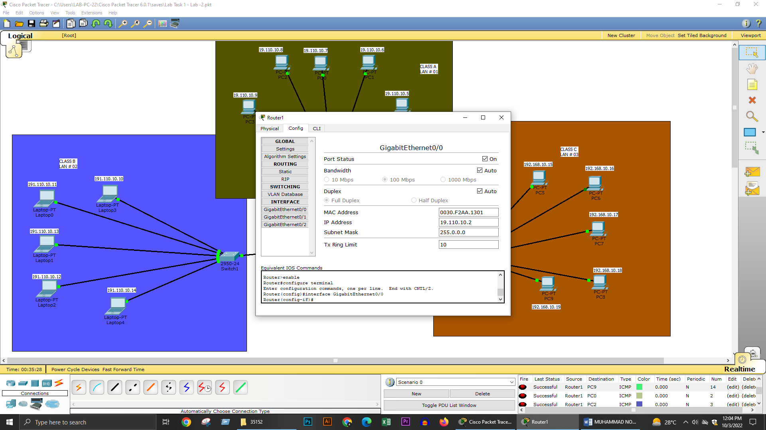

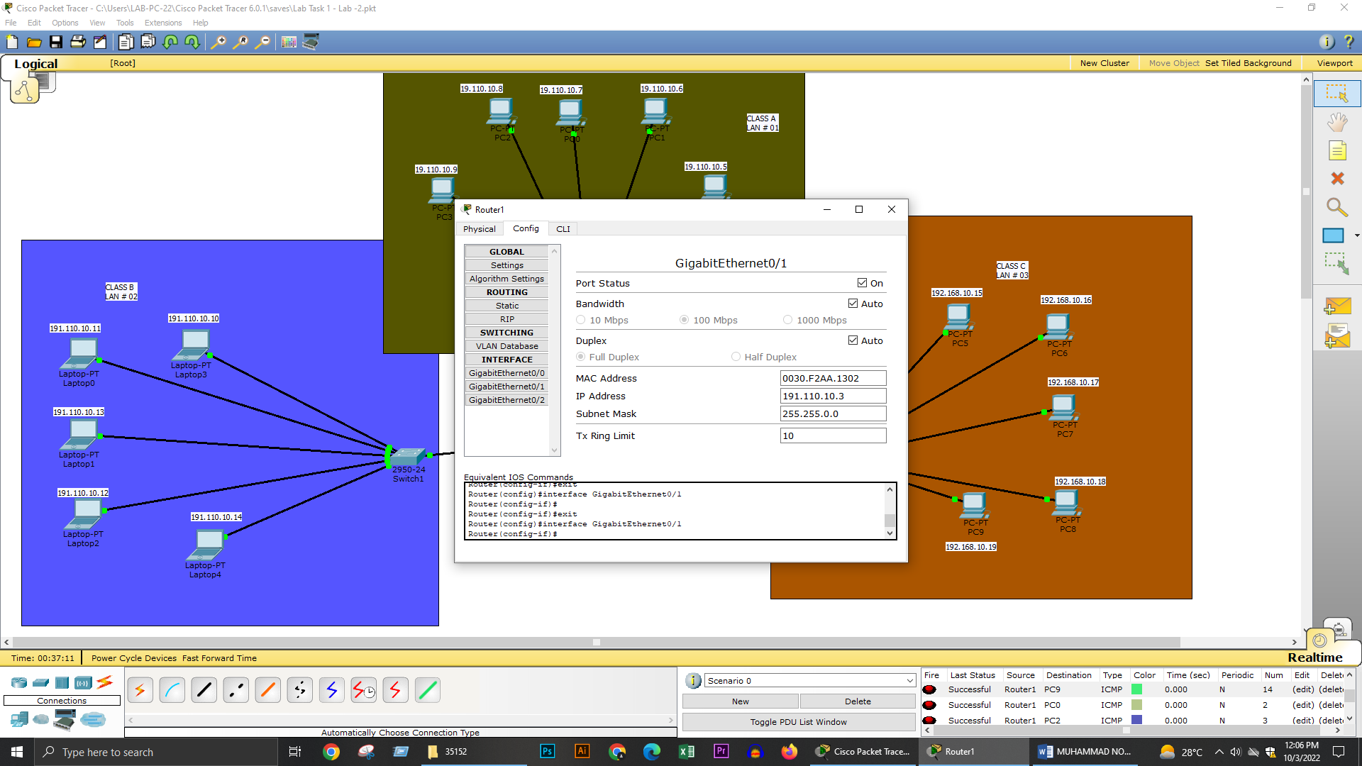

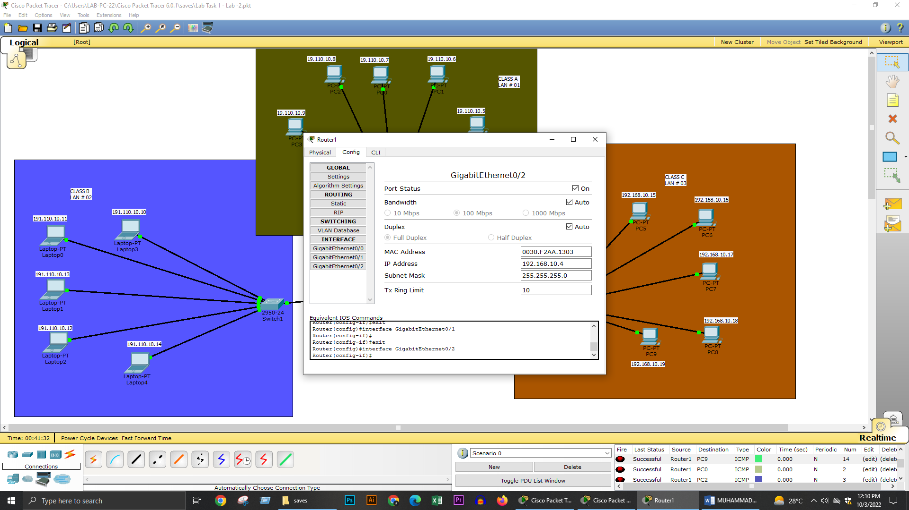

**SYSTEM CONFIGURATION:**

**LAN # 1**

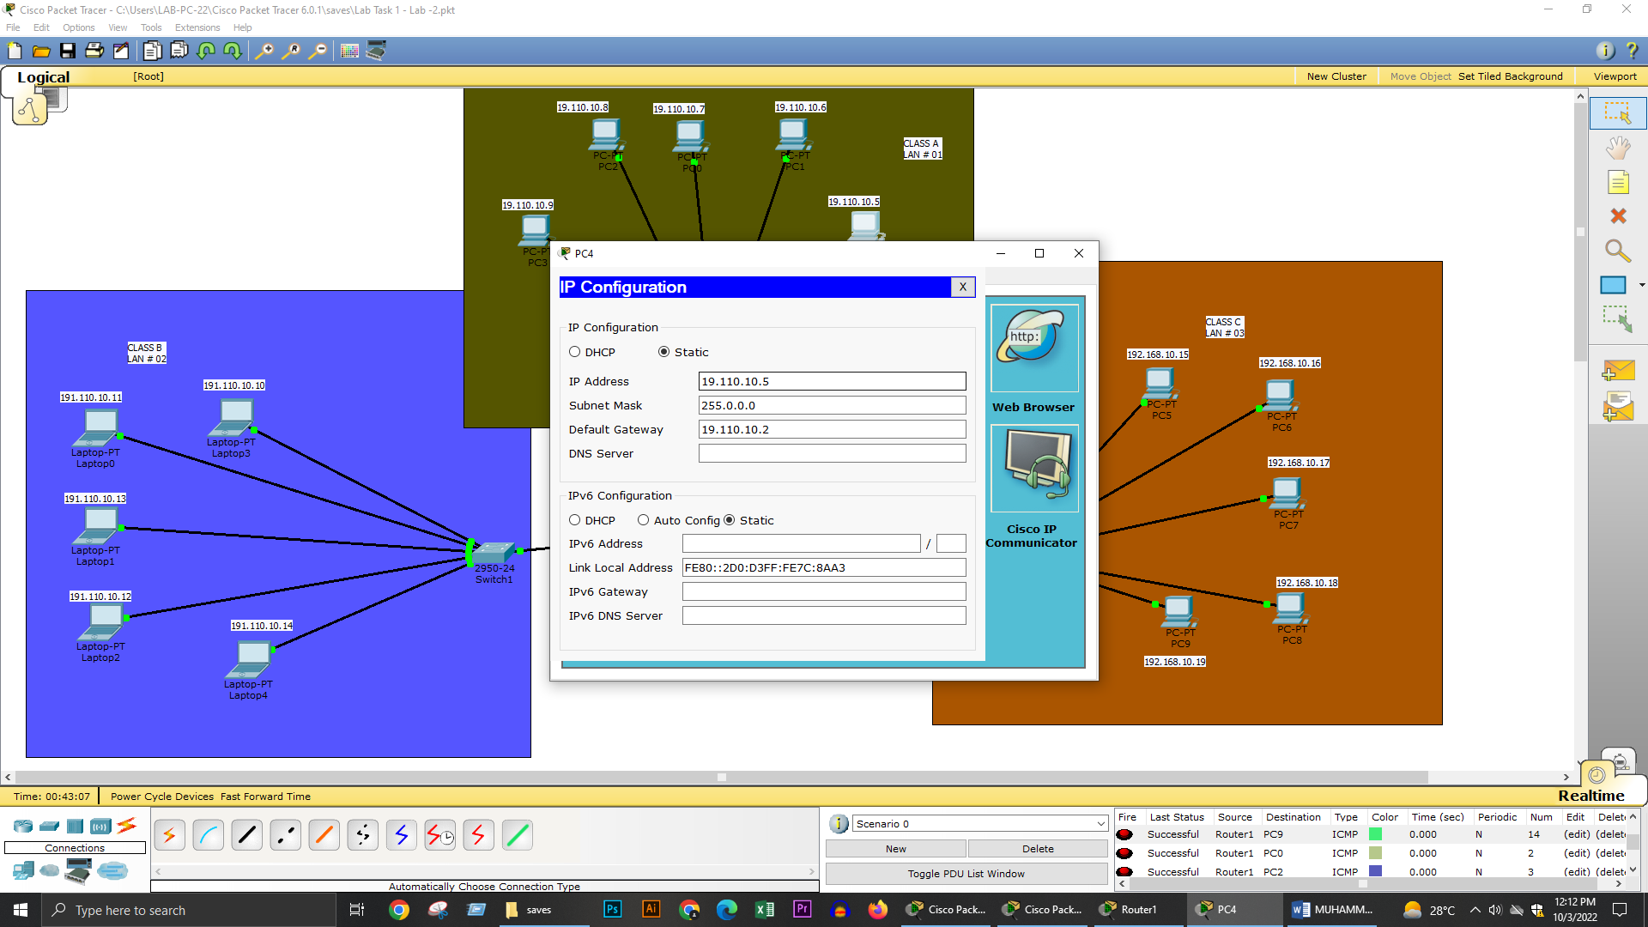

**LAN # 2**

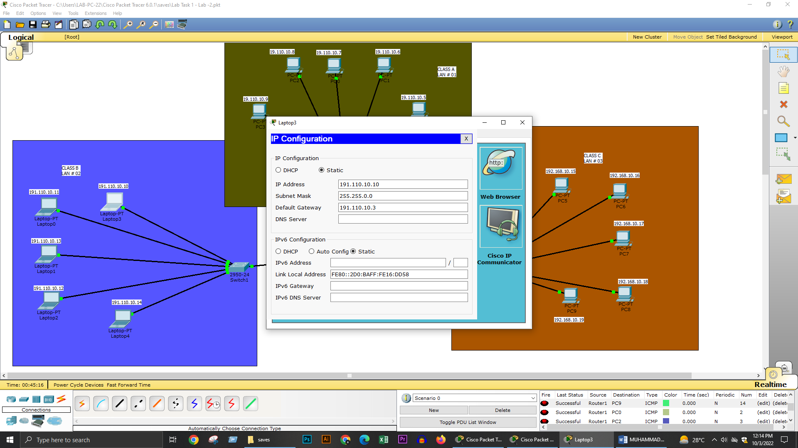

**LAN # 3**

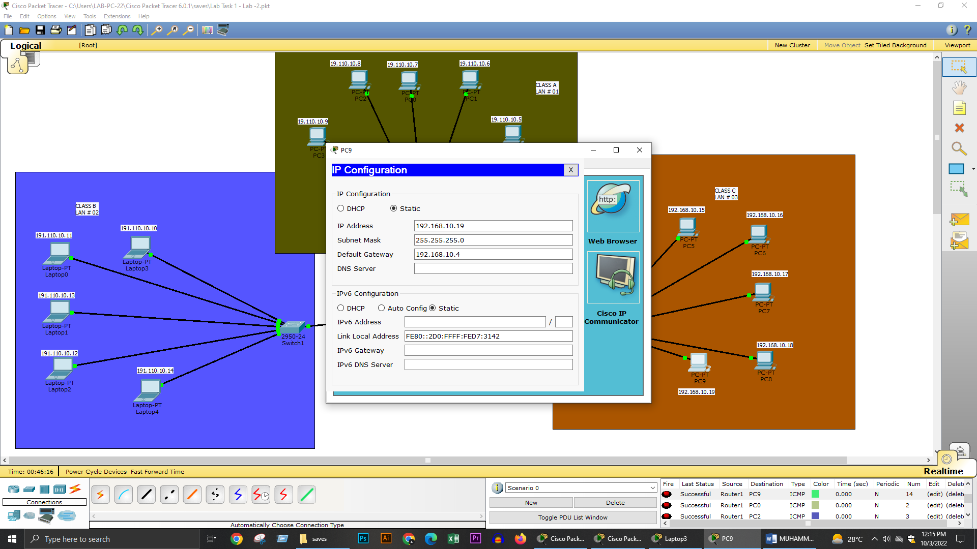

**PACKET DROPPING FROM ROUTER TO PC:**

**LAN # 01 : OUTPUT**

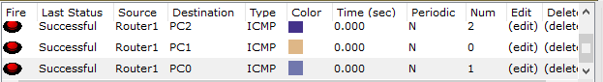

**LAN # 02 : OUTPUT**

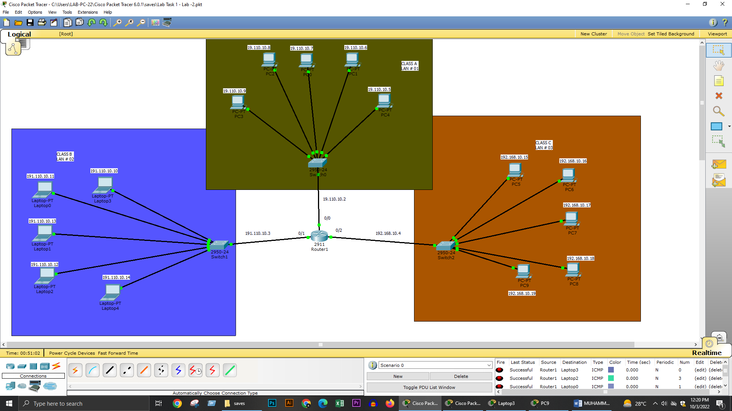

**LAN # 03 : OUTPUT**

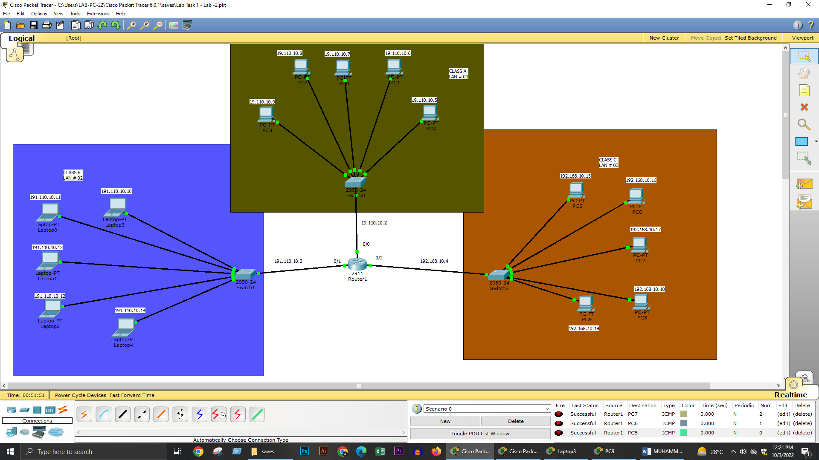

**PACKET PLACING FROM SYSTEM TO SYSTEM:**

